Protecting yourself from scams and staying safe on line
  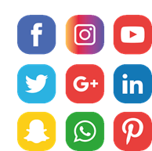   | When:  Wednesday 18 June, 2026.  The talk starts at 7 pm, Melbourne time.  It finishes at 8pm.  About this talk:  This is a talk about staying safe online and on social media.
 | Presenters:  The talk is with Down Syndrome Australia, Digital Champions.  They are leaders with intellectual disability.  They help other people learn to use technology and stay safe online.
 | What the talk will cover  Staying safe on social media. This includes Facebook, Instagram and TikTok.
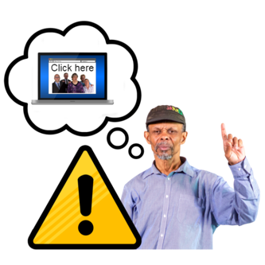 | Scams. A scam is when someone tries to trick you.
 | Relationship scams. This is when someone pretends to be your friend or partner.  They do this to trick you.
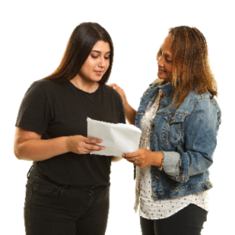 | What to do if you think something is a scam.  They will talk about who you can tell and how to get help.
   | How to join the talk  The talk is online.  It will be on Zoom.  You can use a computer, tablet or phone.  A Zoom link will be sent to you before the session
  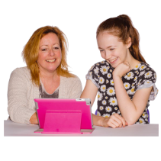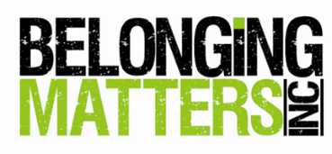     | You will need to register first.  Here is the link to register: Protecting yourself from scams  You can ask a friend, family member or support person to help you.  Belonging Matters is hosting the webinar  If you have any questions please:  Email: info@belongingmatters.org  Phone: 03 9739 8333

